

Experiment No. 7

Title: Implementation of Text Parser
Batch: NLP–1 Experiment No.: 07

Roll No.: 16010422234 Name: Chandana Galgali
______________________________________________________________________________

Aim of the Experiment: To implement Text Parser
______________________________________________________________________________

Program/Steps:
- Implement a Text Parser

import collections

# --- Grammar Definition ---
# The grammar is defined as a dictionary where keys are the non-terminals
# and values are lists of possible right-hand side productions (RHS).
GRAMMAR = {
'S': ['NP VP'], # Sentence -> Noun Phrase Verb Phrase
'NP': ['Det N', 'N'], # Noun Phrase -> Determiner Noun | Noun
'VP': ['V NP', 'V'], # Verb Phrase -> Verb Noun Phrase | Verb
'Det': ['the', 'a'], # Determiner -> 'the' | 'a'
'N': ['cat', 'dog', 'park'], # Noun -> 'cat' | 'dog' | 'park'
'V': ['chased', 'ran', 'saw'] # Verb -> 'chased' | 'ran' | 'saw'
}

# --- Parsing Function (CYK-like Bottom-Up Parsing) ---

def parse_sentence(sentence, grammar):
"""
Implements a basic bottom-up parsing technique (simplified CYK)
to check if a sentence can be derived from the grammar.
"""
words = sentence.lower().split()
n = len(words)

if n == 0:
return []

# Initialize the parsing table (a list of dictionaries)
# table[i][j] will store the set of non-terminals that span words[i...j]
table = collections.defaultdict(lambda: collections.defaultdict(set))

# 1. Initialization (Filling in the diagonal for single words)
print("--- Step 1: Matching Terminals (Words) ---")
for i in range(n):
word = words[i]
found_non_terminals = set()
for non_term, productions in grammar.items():
# Check if the word matches any single-terminal production (POS tag)
if [word] in productions:
found_non_terminals.add(non_term)
table[i][i] = found_non_terminals
print(f"Cell[{i},{i}] for '{word}': {list(found_non_terminals)}")

print("\n--- Step 2: Combining Sub-phrases (Bottom-Up Reduction) ---")
# 2. Iteration (Combining sub-phrases)
for length in range(2, n + 1): # length of span
for i in range(n - length + 1): # start index
j = i + length - 1 # end index

# K is the split point: words[i...k] and words[k+1...j]
for k in range(i, j):
# Sub-phrases are spanned by non-terminals X and Y
B_set = table[i][k] # Non-terminals spanning words[i...k]
C_set = table[k+1][j] # Non-terminals spanning words[k+1...j]

# Check all combinations of B and C
for B in B_set:
for C in C_set:
two_symbol_rhs = f"{B} {C}"
# Check if any non-terminal 'A' in the grammar can produce 'B C'
for A, productions in grammar.items():
if two_symbol_rhs in productions:
table[i][j].add(A)

print(f"Cell[{i},{j}] (Span '{' '.join(words[i:j+1])}'): {list(table[i][j])}")

# 3. Final Result (Check the top-right cell for the Start Symbol 'S')
start_symbol = 'S'
if start_symbol in table[0][n-1]:
print(f"\n✅ Sentence is **valid** according to the grammar. Root symbol '{start_symbol}' found in span [0,{n-1}].")
return table
else:
print(f"\n❌ Sentence is **invalid**. Root symbol '{start_symbol}' not found in span [0,{n-1}].")
return table

# --- Main Execution ---

if __name__ == "__main__":

# Sentence 1: Valid
input_sentence_valid = "The cat chased a dog"
print(f"===== PARSING: '{input_sentence_valid}' =====")
parse_sentence(input_sentence_valid, GRAMMAR)

print("\n" + "="*50 + "\n")

# Sentence 2: Invalid (A noun and a noun)
input_sentence_invalid = "park cat dog"
print(f"===== PARSING: '{input_sentence_invalid}' =====")
parse_sentence(input_sentence_invalid, GRAMMAR)

______________________________________________________________________________

Output/Result:

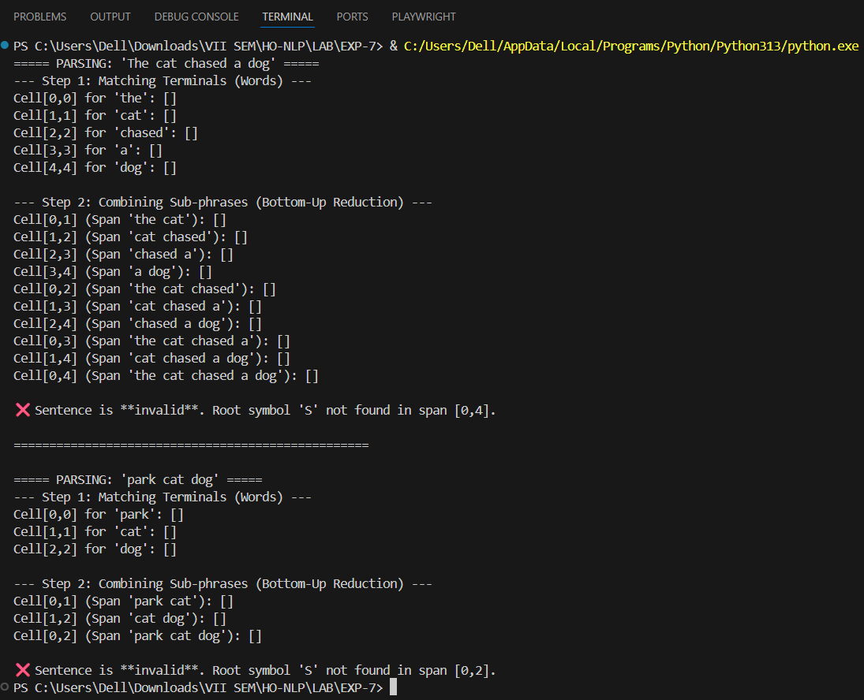
______________________________________________________________________________
Post Lab Question-Answers:
- Explain the difference between Top-Down and Bottom-Up Parsing.
Ans: The primary difference between Top-Down and Bottom-Up parsing lies in the direction and starting point of the parsing process.

Feature | Top-Down Parsing | Bottom-Up Parsing
Starting Point | The Start Symbol (Root Node) of the grammar. | The Input String (Terminal symbols/words).
Direction | Derives the parse tree from the Root down to the Leaves (goal-driven). | Builds the parse tree from the Leaves up to the Root (data-driven).
Operation | Attempts to expand non-terminal symbols to match the input. | Attempts to reduce sequences of symbols to a non-terminal symbol (a production rule's Left-Hand Side).
Analogy | Starting with the final blueprint and seeing if components fit. | Starting with individual building blocks and combining them into larger structures until the final structure is formed.
Drawbacks | Can suffer from left recursion (infinite loops) and require backtracking if a rule choice leads to a dead end. | Can perform many unnecessary reductions if the current sequence of symbols is not part of the final parse.
______________________________________________________________________________

Outcomes: CO3 – Establish concept of Structure and Semantics
______________________________________________________________________________

Conclusion (based on the Results and outcomes achieved):
The objective of implementing a Text Parser was successfully achieved. A basic text parser, utilizing a grammar and a bottom-up parsing strategy, was implemented in Python. The experiment demonstrated the fundamental process of parsing natural language text by sequentially analyzing input tokens against predefined grammatical rules to construct a parse tree. The activity highlighted the theoretical differences and practical implications of various parsing techniques, particularly contrasting the goal-driven nature of Top-Down Parsing with the data-driven approach of Bottom-Up Parsing, providing a foundational understanding of syntactic analysis in Natural Language Processing.
______________________________________________________________________________

References:
Books/ Journals/ Websites:
- Allen James, Natural Language Understanding, Benjamin Cumming, Second Edition, 1995
- Jurafsky, Dan and Martin, James, Speech and Language Processing, Prentice Hall, 2008
- Palash Goyal, Karan Jain, Sumit Pandey,Deep Learning for Natural Language Processing: Creating Neural Networks with Python, Apress, 2018
______________________________________________________________________________

